Holberton BnB Design Document
Trevor, Sean, and Sierra

Introduction
This document describes the currently planned features, functional layout, and flow of logic of the Holberton BnB (HBnB) website, a web app that allows users to list places they own for renting out, and other users can review those places based on their experience.
HBnB is a recreation of the popular and successful website AirBnB for educational purposes. It is not meant to be as feature-complete as its inspiration, but to learn and demonstrate the usage of data permanence, programming APIs, and creating a web client, in a similar manner to how most websites and apps are created today.

High Level Package Diagram
This diagram represents the configuration of packages that will work together on the HBnB servers.
- The Presentation Layer takes all external requests coming into the server and parses them into calls to the Business Logic Layer.
- The Business Logic Layer performs the requested operations from the Presentation Layer, such as registering a User, Place, or Review, or changing attributes of those classes. Changing, adding, or removing data will cause a request to the Persistence Layer to permanently save the change.
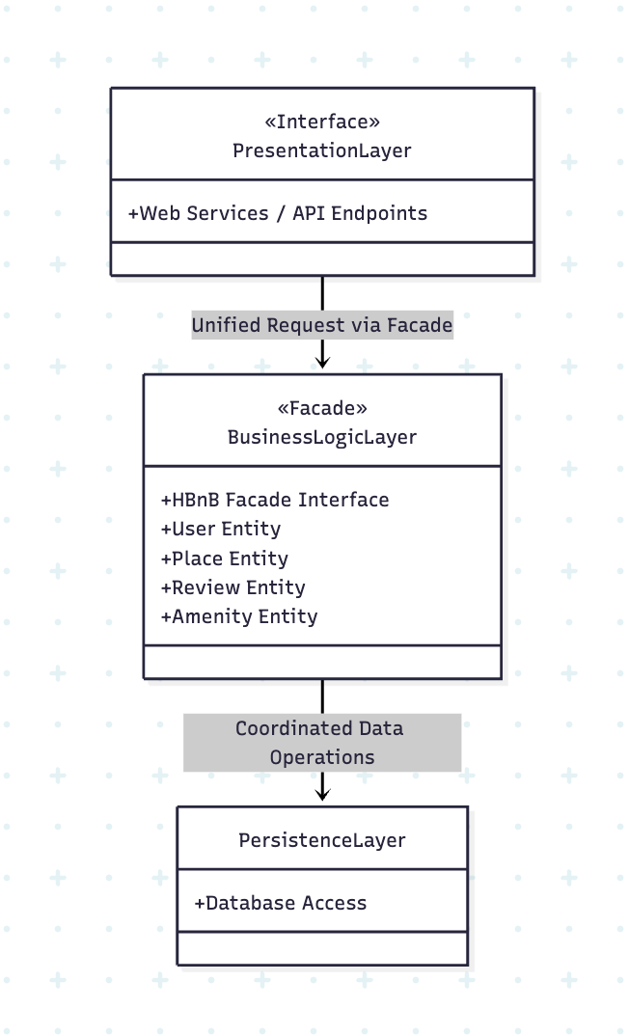
- The Persistence Layer represents the database of HBnB. This layer will load and save data to long-term storage at the request of the Business Logic Layer, and prevents losing data in the event that the server is shut down for any reason.

Business Logic Class Diagram
This diagram represents the definitions and relationships of the classes in the Business Logic Layer
- An instance of User represents a real person using the HBnB system. It could be an admin user but defaults to false. An instance of User is required to create and manage a Place and create and manage a Review
- An instance of Place represents a registered location on HBnB. It has one User in control of it and a list of Amenities specific to it, alongside other descriptive attributes like location and price. The static method "list" takes coordinates and will return a list of places nearby the coordinates.
- An instance of Review represents an informative review of a Place written by a User. The static method "list" will take a Place and return a list of reviews for the given place.
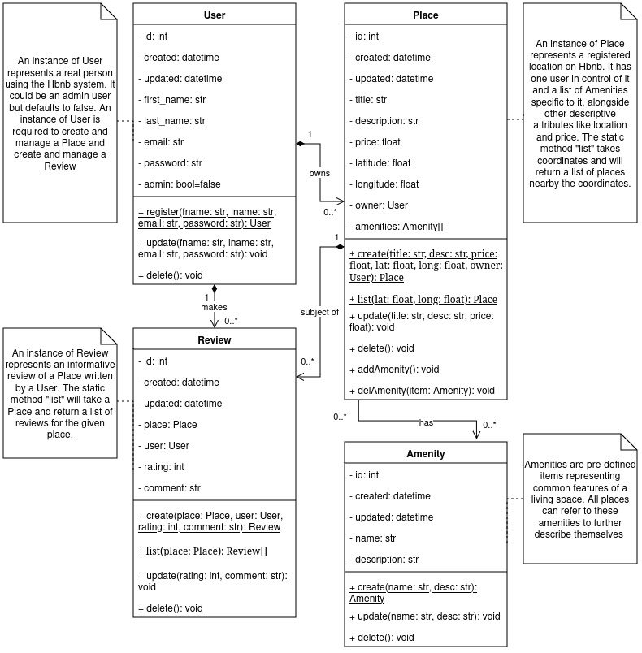
- Amenities are pre-defined items representing common features of a living space. All Places can refer to these amenities in an internal list to further describe themselves

Sequence Diagrams
The following sequence diagrams detail the order of calls between the user and each package in different scenarios.

User Registration
In this scenario, a real person wants to register as a new user in the HBnB website. It starts with a submission of information to the Presentation Layer, which then parses and passes the information to the Business Logic layer. If there is an issue with the supplied data, the operation stops and an error is raised back to the Presentation Layer for the user to review. Otherwise, the data for the new user is sent to the Persistence Layer to permanently save, and a status to whether the save succeeded or failed is raised back to the Presentation Layer.
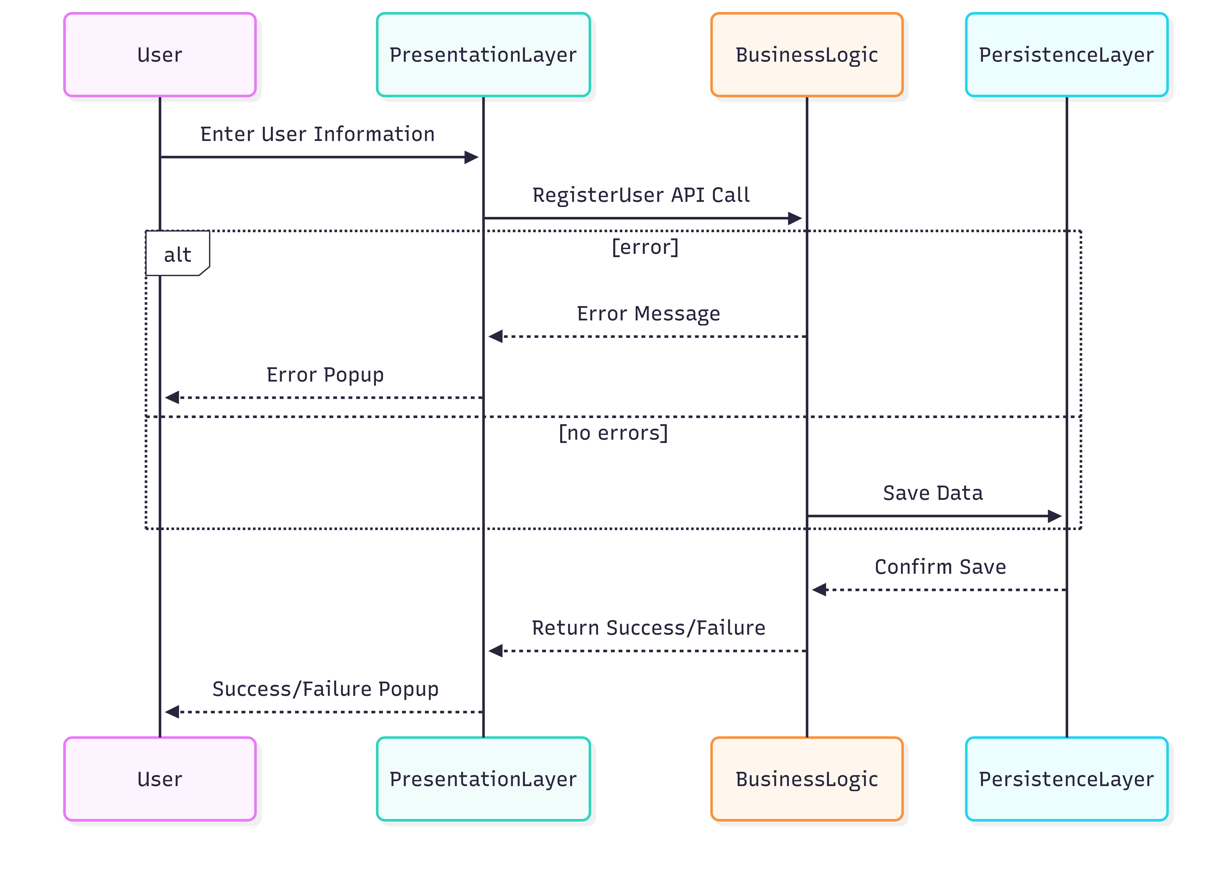

Place Creation
Registering a place on HBnB is very similar to registering a new user as described above. A user submits the information required to register a new place via the Presentation Layer, which is then passed to the Business Logic Layer for validation and computing. If the given data is invalid, such as this is attempted without an associated user logged in, an error is raised to the Presentation Layer. Otherwise, the compiled data is passed to the Persistence Layer for saving, and the success or failure of this is raised back up to the Presentation Layer.

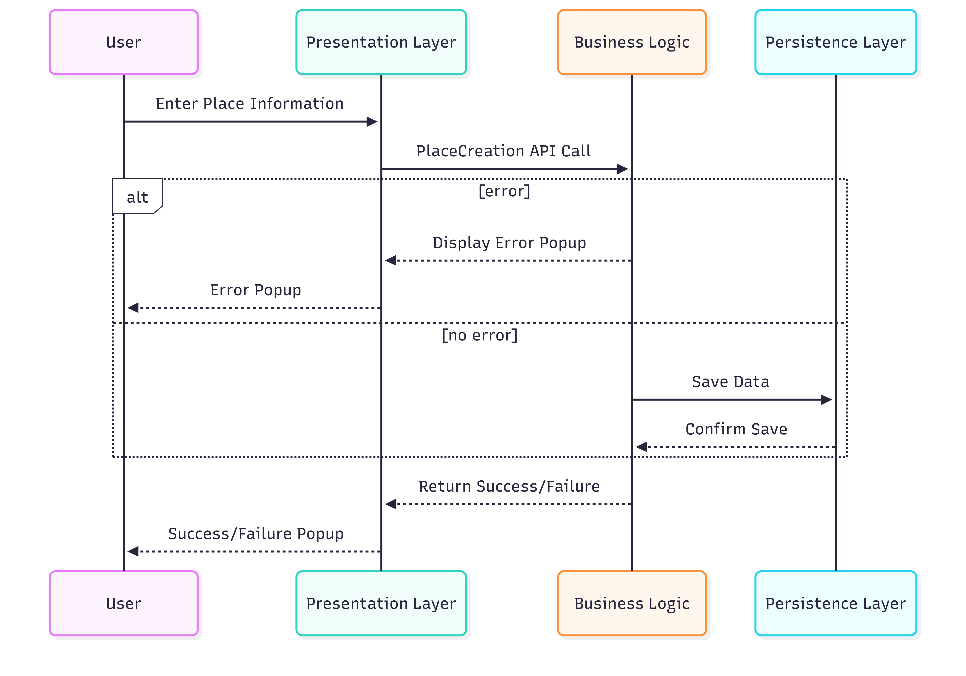
Submit Review
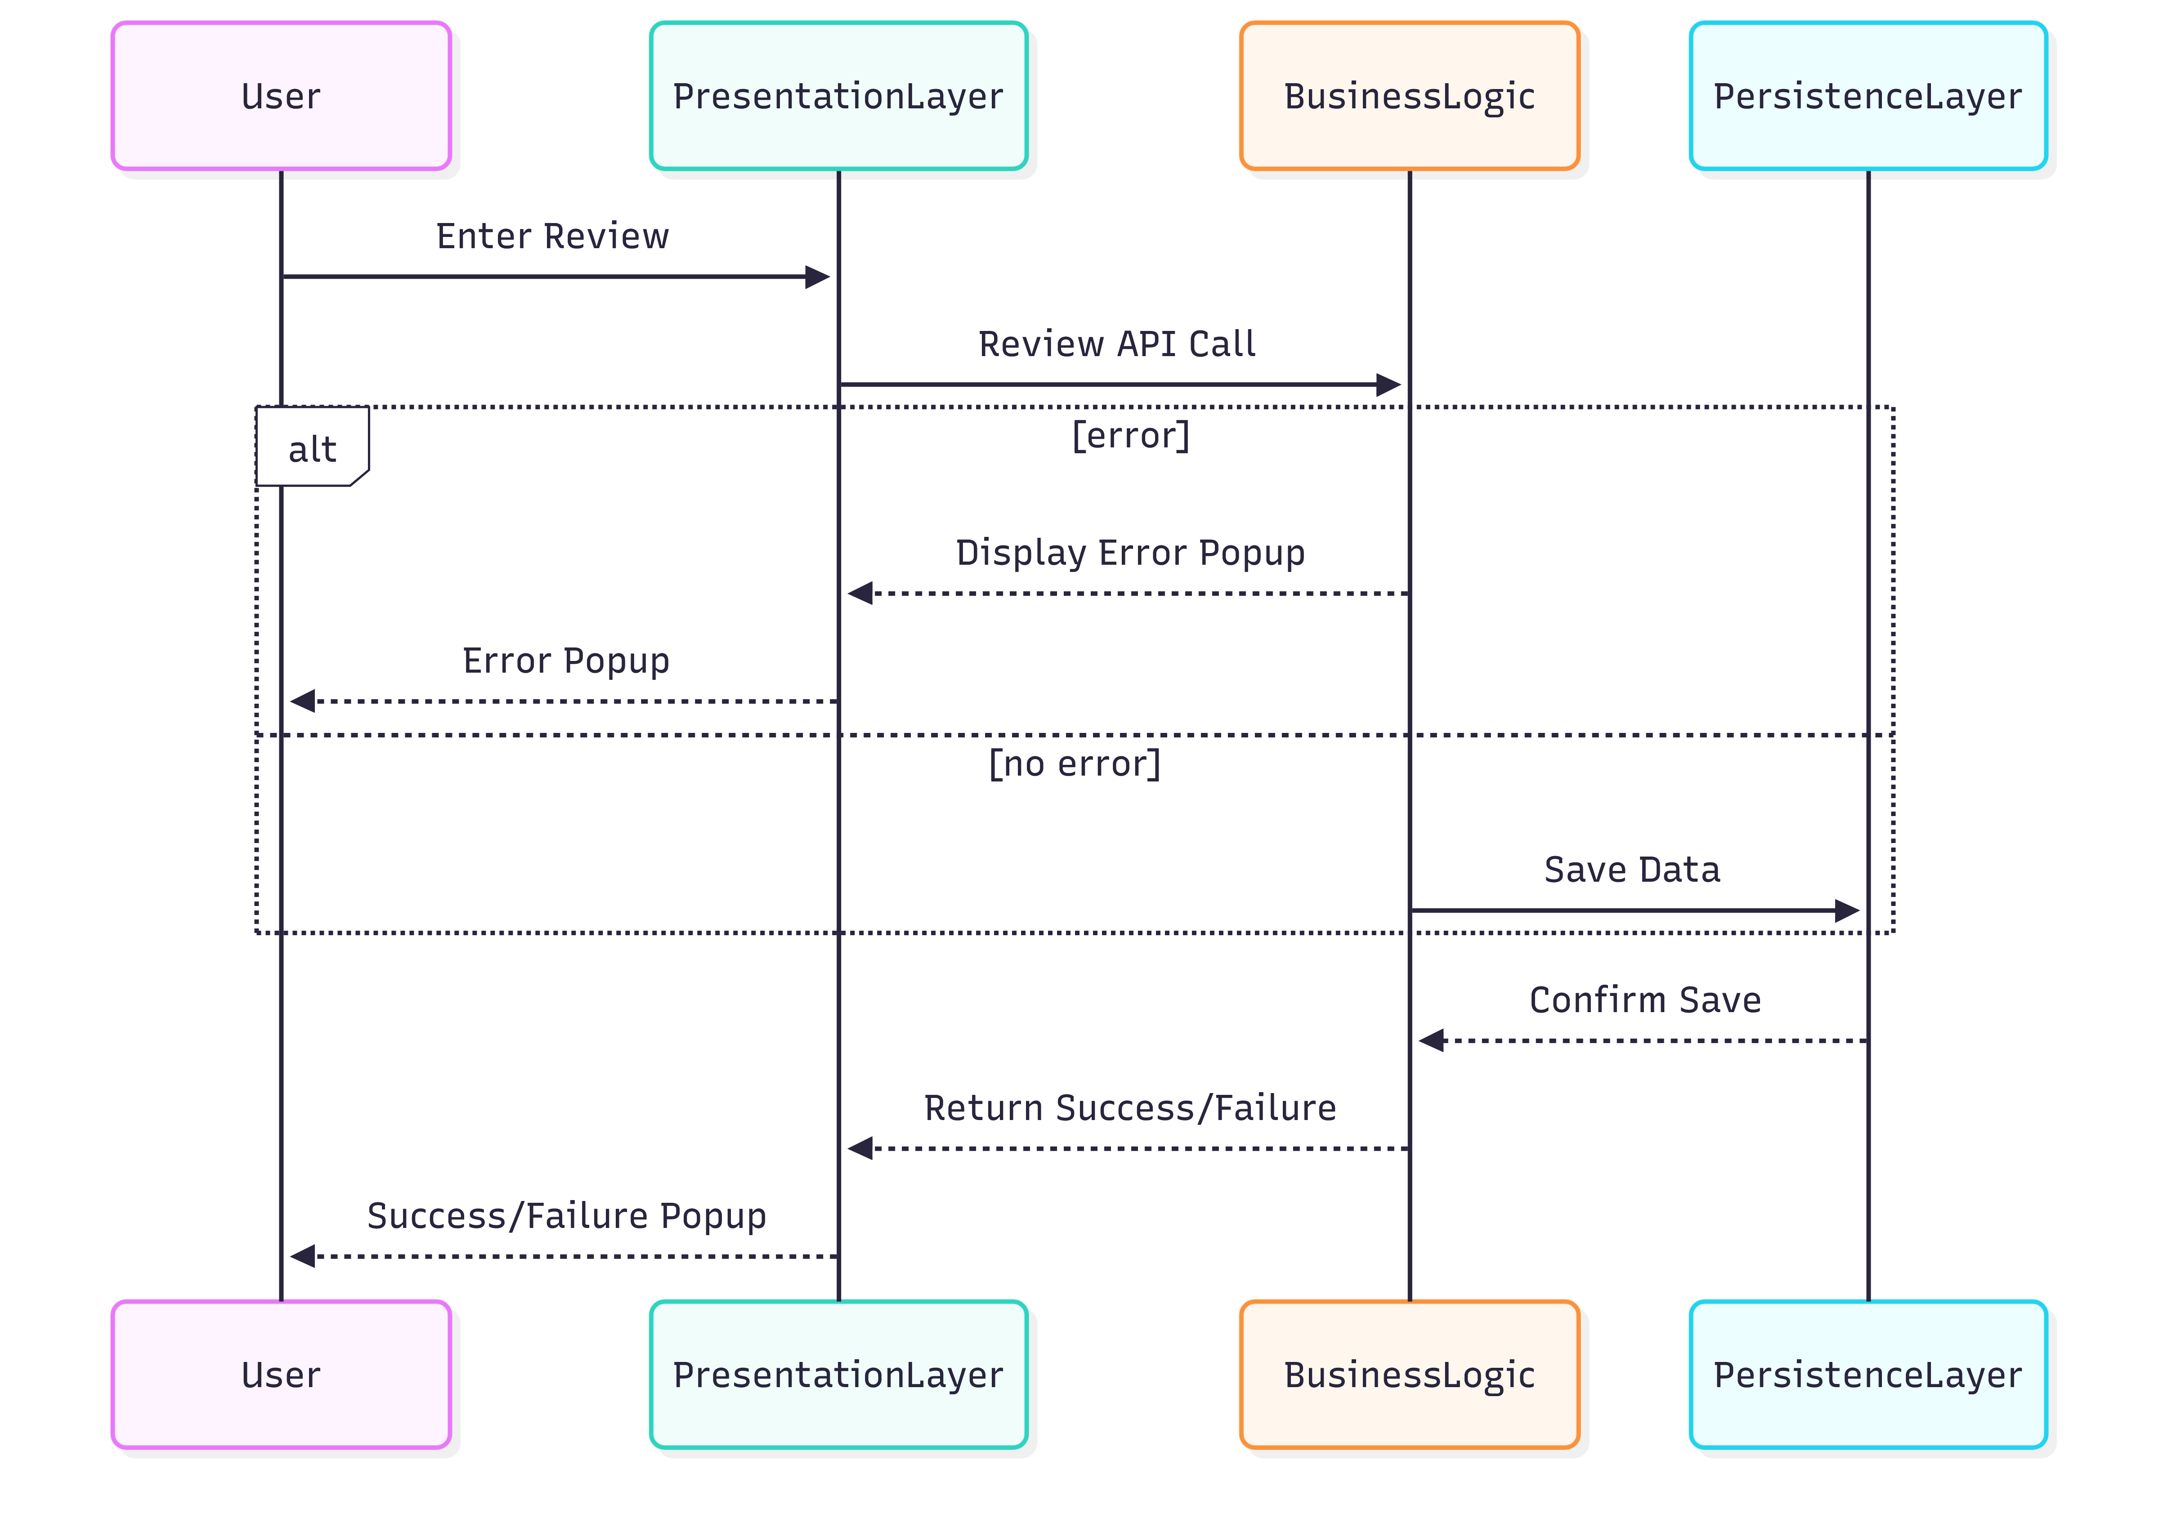
Again, the process for creating a review is very similar to the two diagrams above. A user submits the information for a review via the Presentation Layer, the Business Logic Layer validates it, passes the information to the Persistence Layer to save, and the outcome is raised back to the Presentation Layer. If the data is invalid, the Business Logic Layer raises an error to the Presentation Layer.

Fetching List of Places
Visitors to HBnB will be able to view a list of currently registered places. This is done by providing a request for this list with or without filters via the Presentation Layer. The Presentation Layer passes the request and filters to the Business Logic Layer, which forms a request using any provided filters and gives the request to the Persistence Layer. The places which match the filters will be returned to the Business Logic Layer, and the list is finally passed back to the Presentation Layer.
